**PART 1:**

1. Take a list of elements from the user and find the square root of each member in the list and store in it another list and store it in another list and print that list.

Program:

import math  
  
num = []  
root_list = []  
  
print("Enter elements of list (Enter 'n' to stop): ")  
while True:  
 x = input("Enter element: ")  
 if x=='n':  
 break  
 else:  
 num.append(int(x))  
  
for i in range(0,len(num)):  
 root_list.append(math.sqrt(num[i]))  
  
print(root_list)

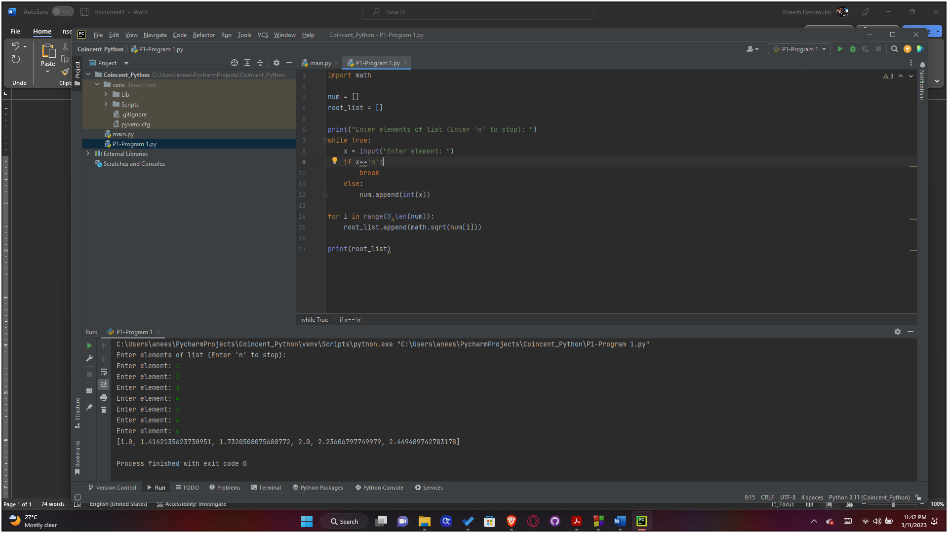Output:

1. Write a function that prints all the numbers divisible by 3 and 5.

Program:

**n = int(input("Enter the number upto which you want to print the numbers divisible by 3 and 5: "))  
  
for i in range(1,n+1):  
 if i % 3 == 0 and i % 5 == 0:  
 print(i, end=" ")**

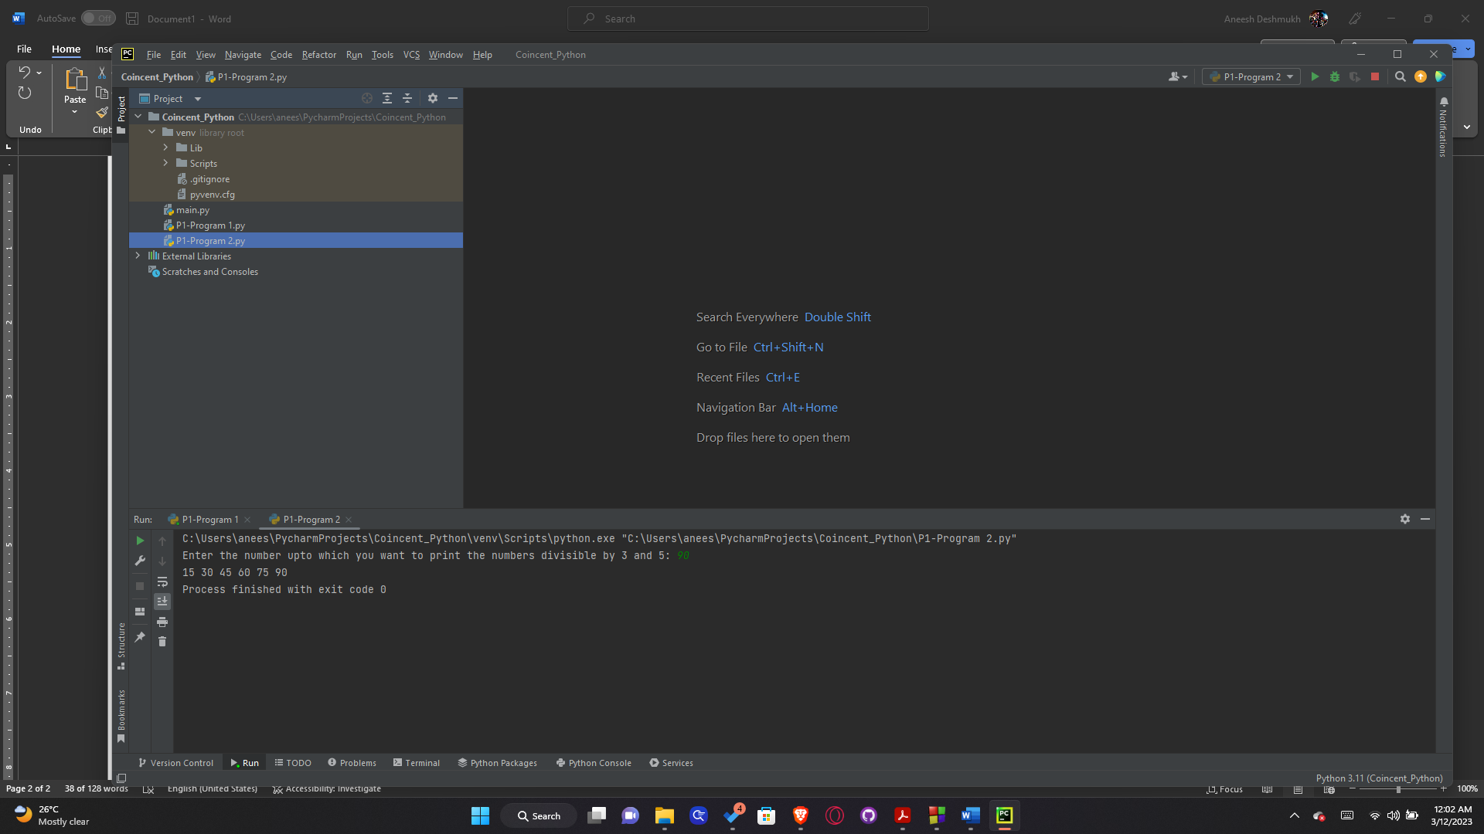Output:

1. Write a program to check whether a given letter is a vowel or a consonant.

Program:

x = input("Enter letter to checked: ")  
  
if x in "aeiouAEIOU":  
 print("Vowel")  
else:  
 print("Consonant")

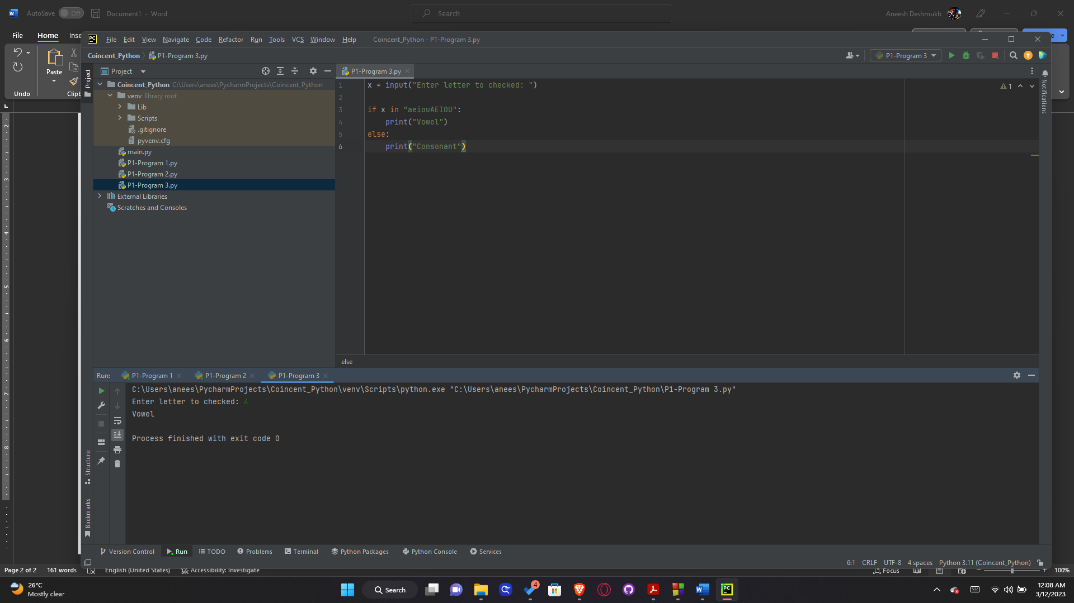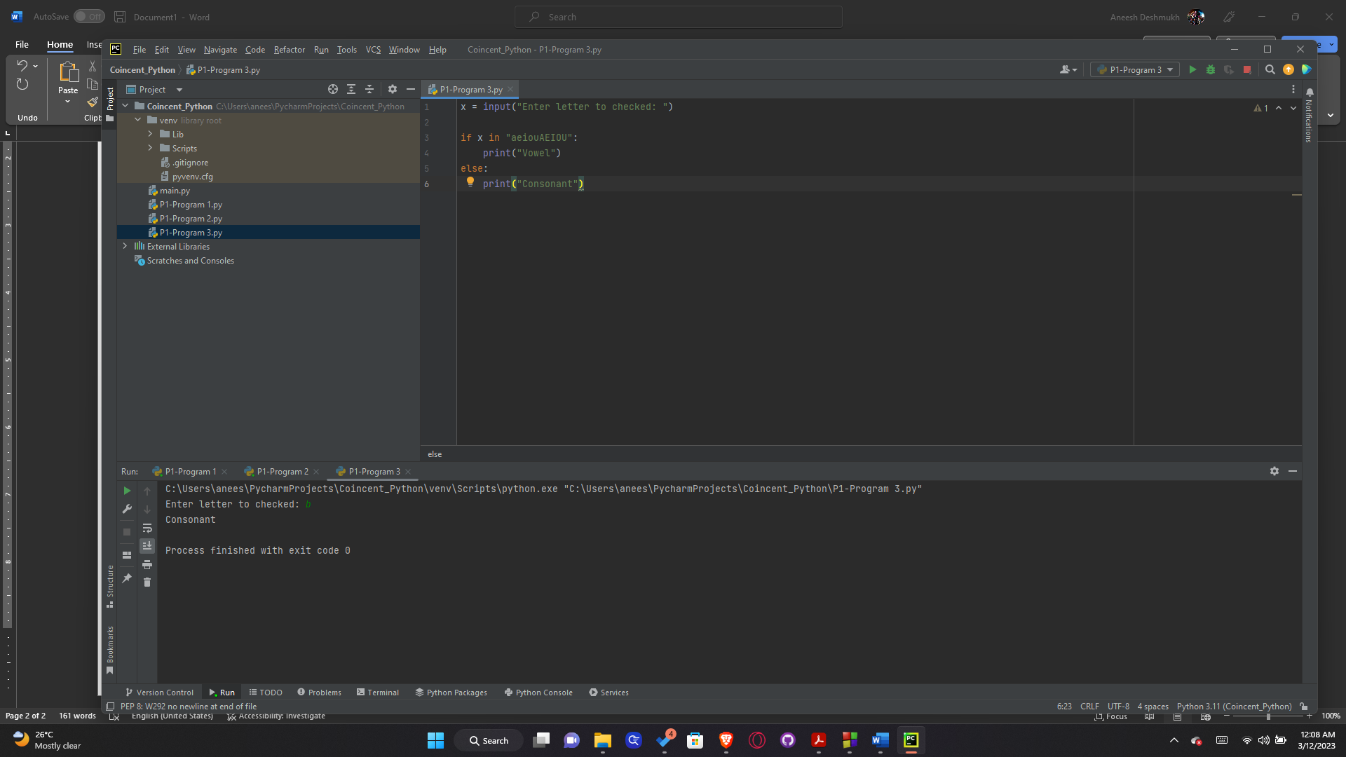Output:

1. Calculate the distance between any two characters given by user.

Program:

x = input("Enter first character: ")  
y = input("Enter second character: ")  
  
print(abs(ord(x)-ord(y)))

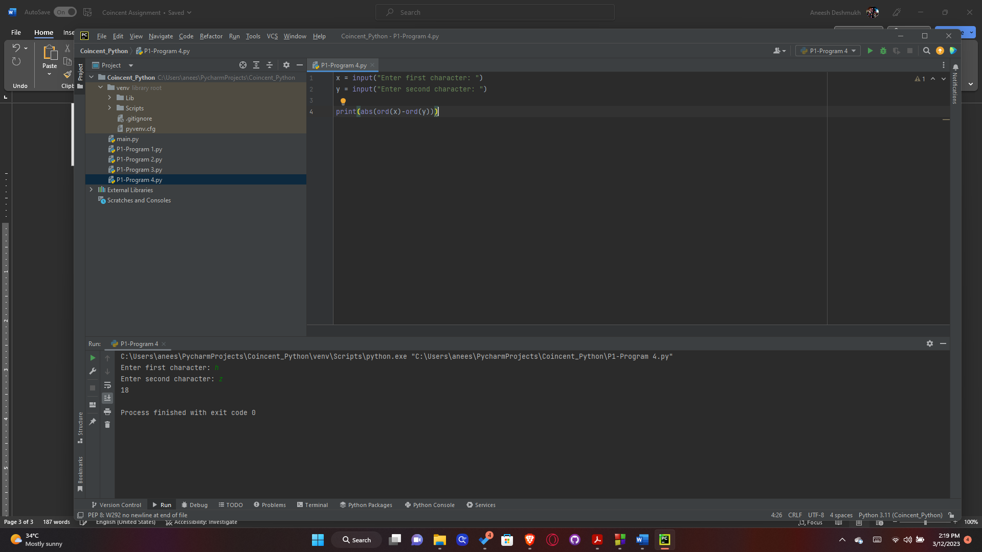Output:

1. Write a function which returns the number of vowels present in the given string.

Program:

s = input("Enter string: ")  
count = 0  
  
for i in s:  
 if i in "aeiouAEIOU":  
 count+=1  
  
print("There are " + str(count) + " vowels in the given string.")

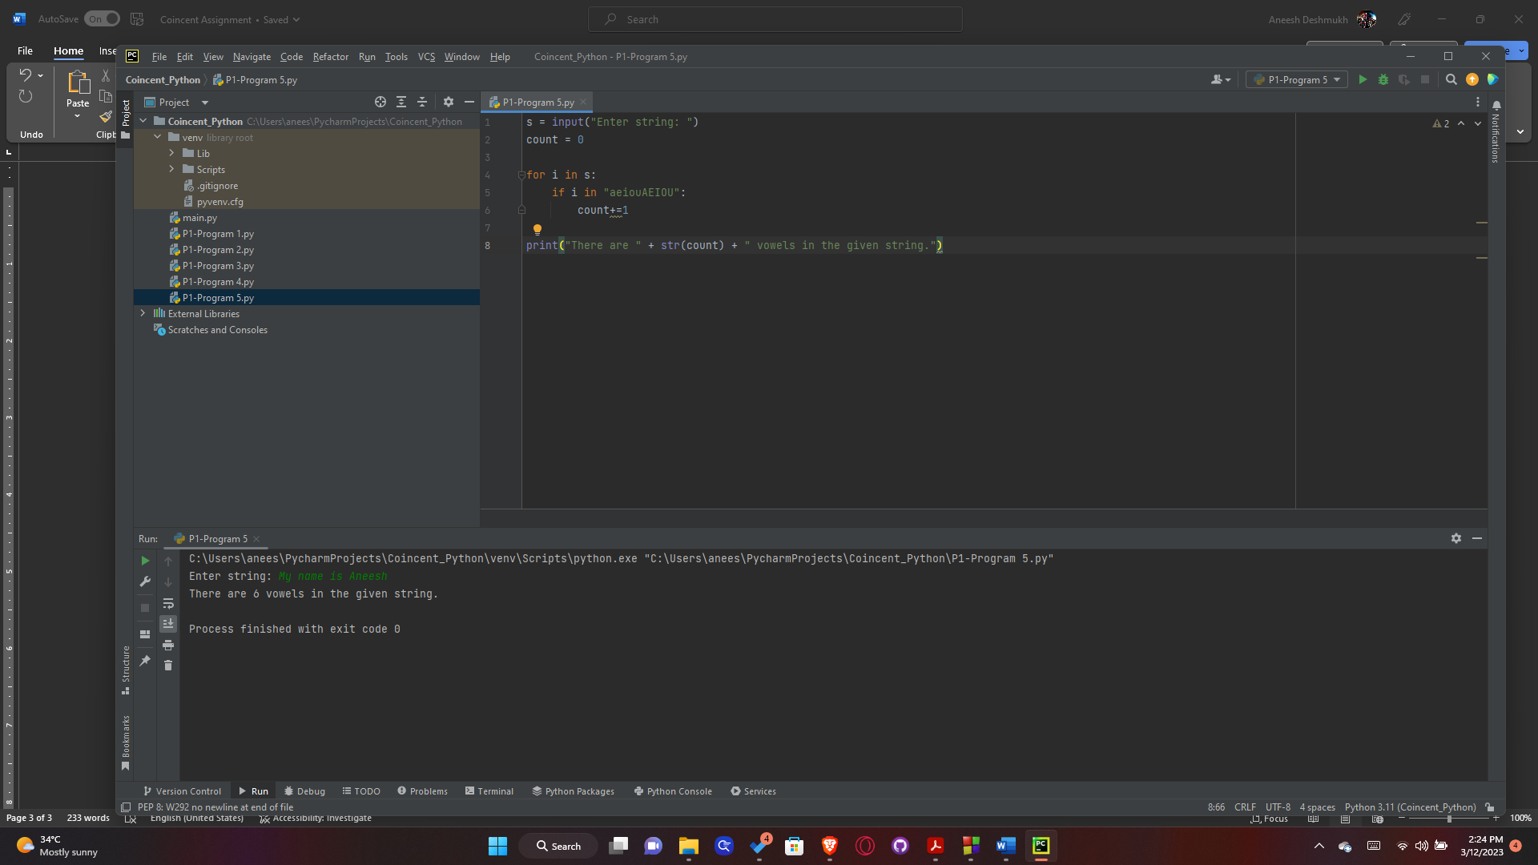Output:

1. Print all the alphabets using loop and ascii code.

Program:

for i in range(65, 91):  
 print(chr(i), end=" ")  
  
print()  
  
for i in range(97, 123):  
 print(chr(i), end=" ")

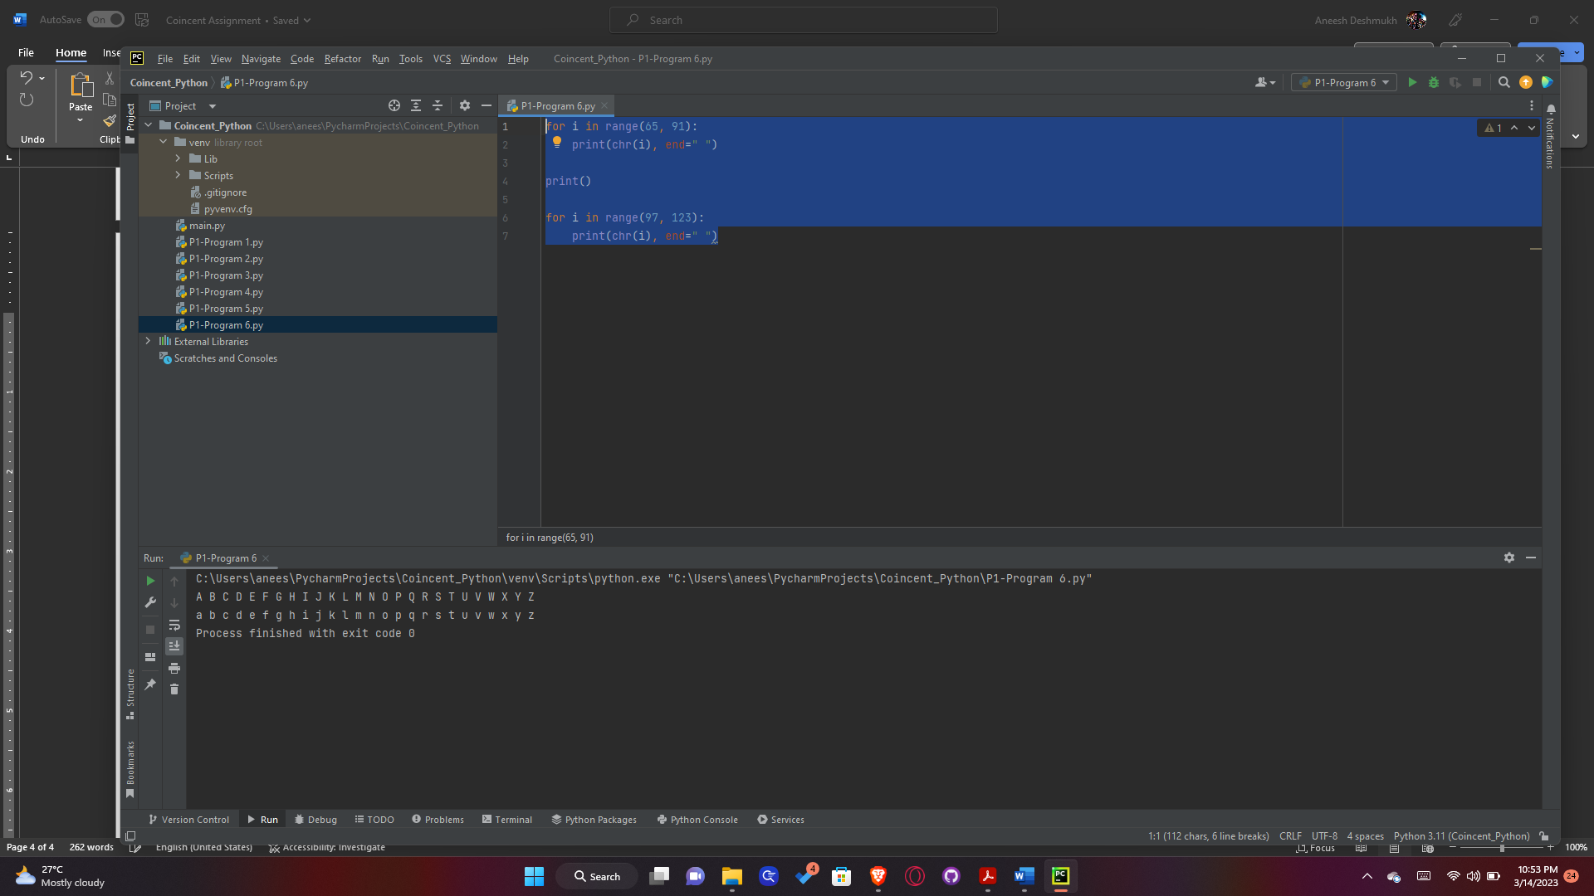Output:

1. Write a program to find the sum of all even numbers in a list.

Program:

num_list = []  
  
print("Enter list elements. Press 'n' to stop: ")  
  
while True:  
 x = input()  
 if x == 'n':  
 break  
 num_list.append(int(x))  
  
sum = 0  
  
for i in range(0, len(num_list)):  
 if num_list[i] % 2 == 0:  
 sum += num_list[i]  
  
print(sum)

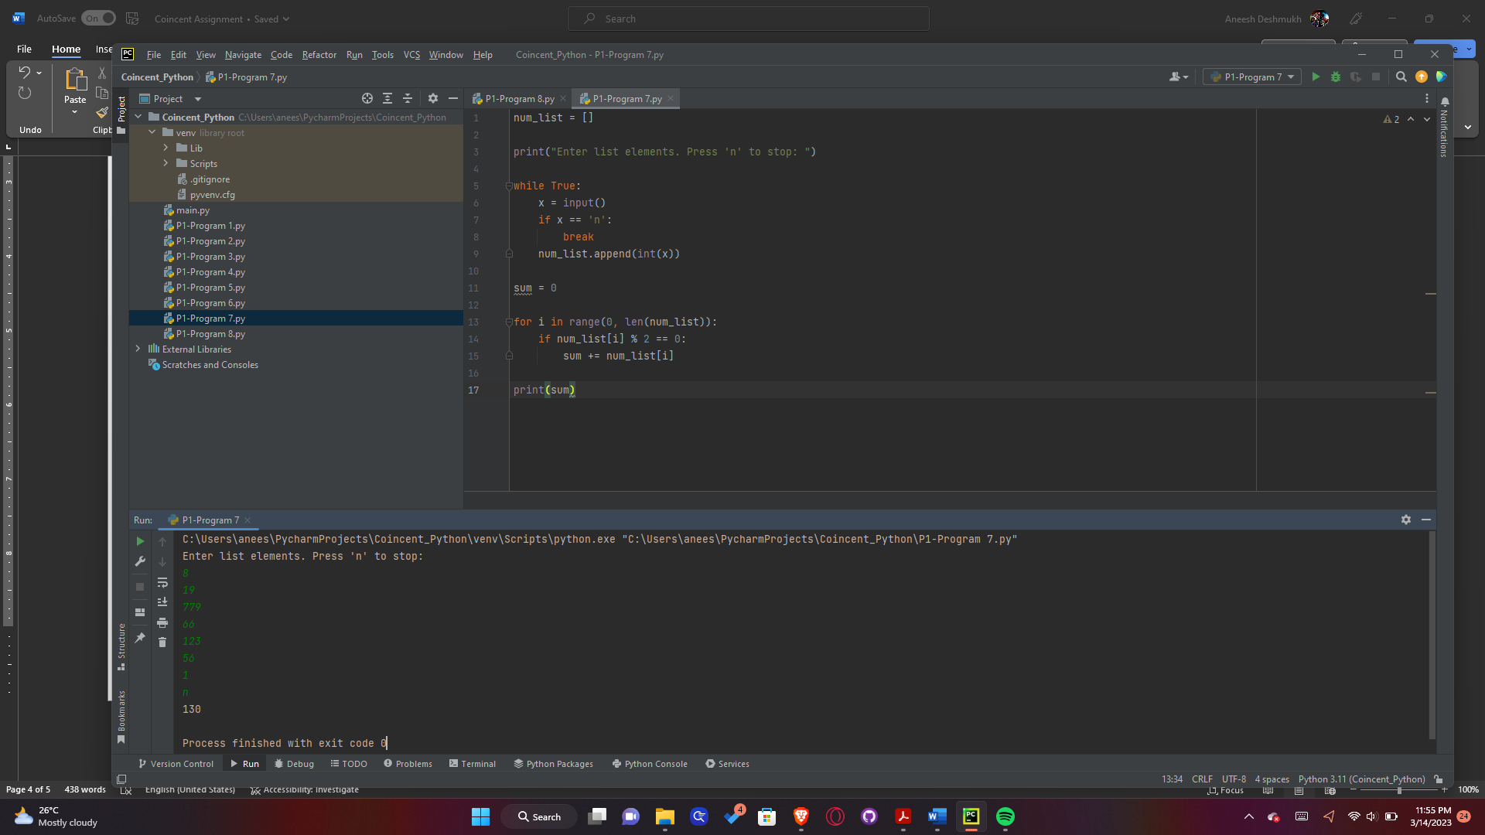Output:

1. Write a program to print the squares of all the numbers, except for factors of 3.

Program:

# excluding FACTORS of 3  
print("Excluding FACTORS of 3: ")  
n = int(input("To avoid an infinite loop, enter the number till which you want to print the squares: "))  
  
for i in range(1, n + 1):  
 if 3 % i == 0:  
 continue  
 else:  
 print(i ** 2, end=" ")  
  
print()  
  
# excluding MULTIPLES of 3  
print("Excluding MULTIPLES of 3: ")  
n = int(input("To avoid an infinite loop, enter the number till which you want to print the squares: "))  
  
for i in range(1, n + 1):  
 if i % 3 == 0:  
 continue  
 else:  
 print(i ** 2, end=" ")

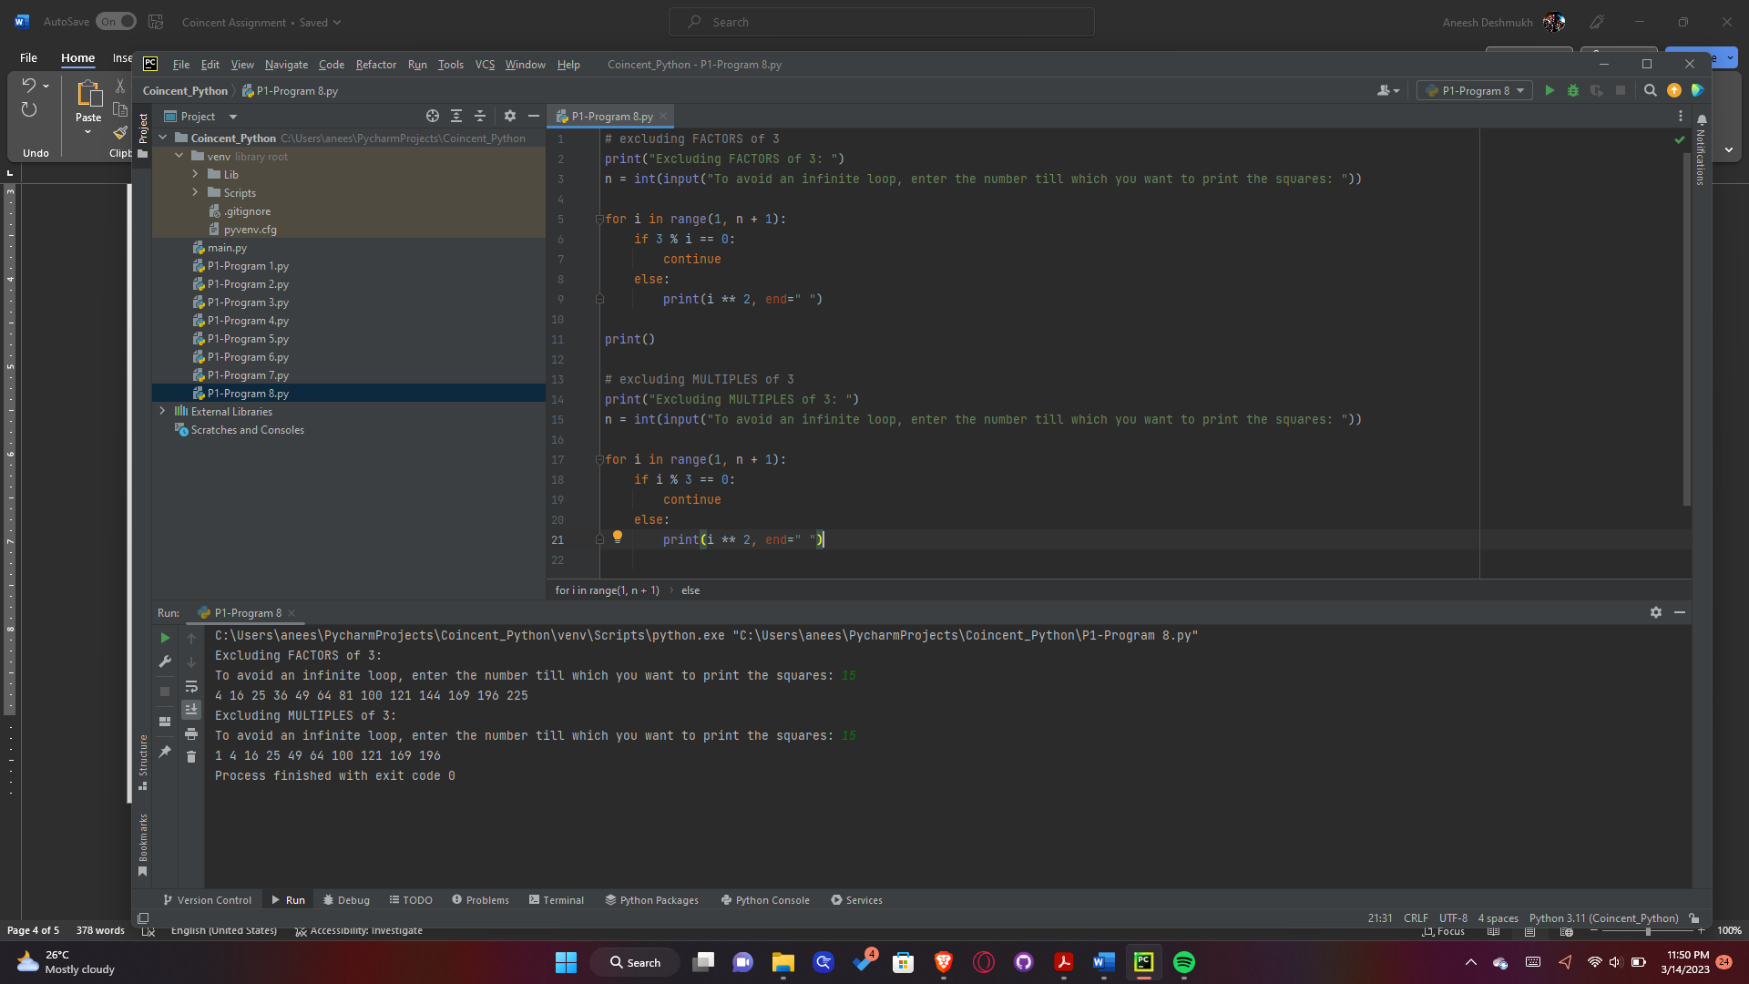Output:

1. Take 2 strings from user and then replace all the A’s with a’s, and then concatenate the 2 strings and print.

Program:

str1 = input("Enter first string: ")  
str2 = input("Enter second string: ")  
  
str1 = str1.replace('A', 'a')  
str2 = str2.replace('A', 'a')  
  
str3 = str1 + str2  
  
print(str3)

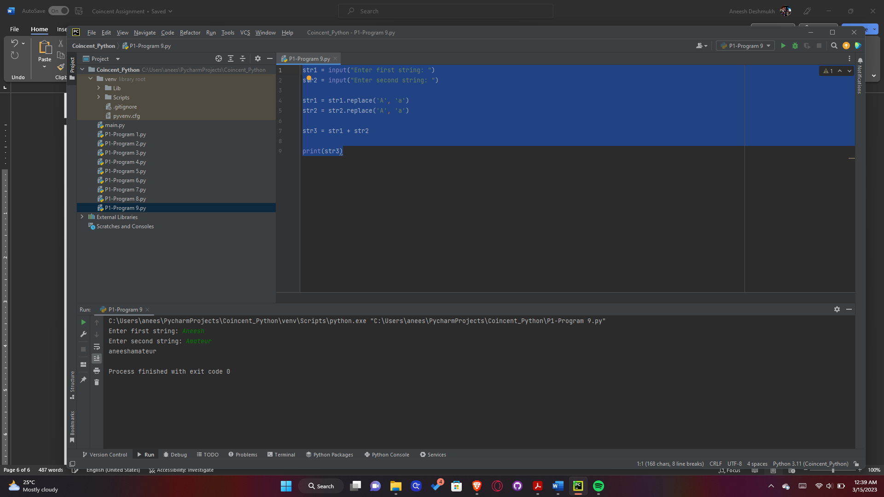Output:

1. Write a program to get a list of odd numbers from the list of numbers given by user (use list comprehension).

Program:

user_list = []  
  
print("Enter elements of list. Enter 'n' to stop")  
  
while True:  
 x = input()  
 if x == 'n':  
 break  
 user_list.append(int(x))  
  
new_list = [x for x in user_list if not x % 2 == 0]  
  
print(new_list)

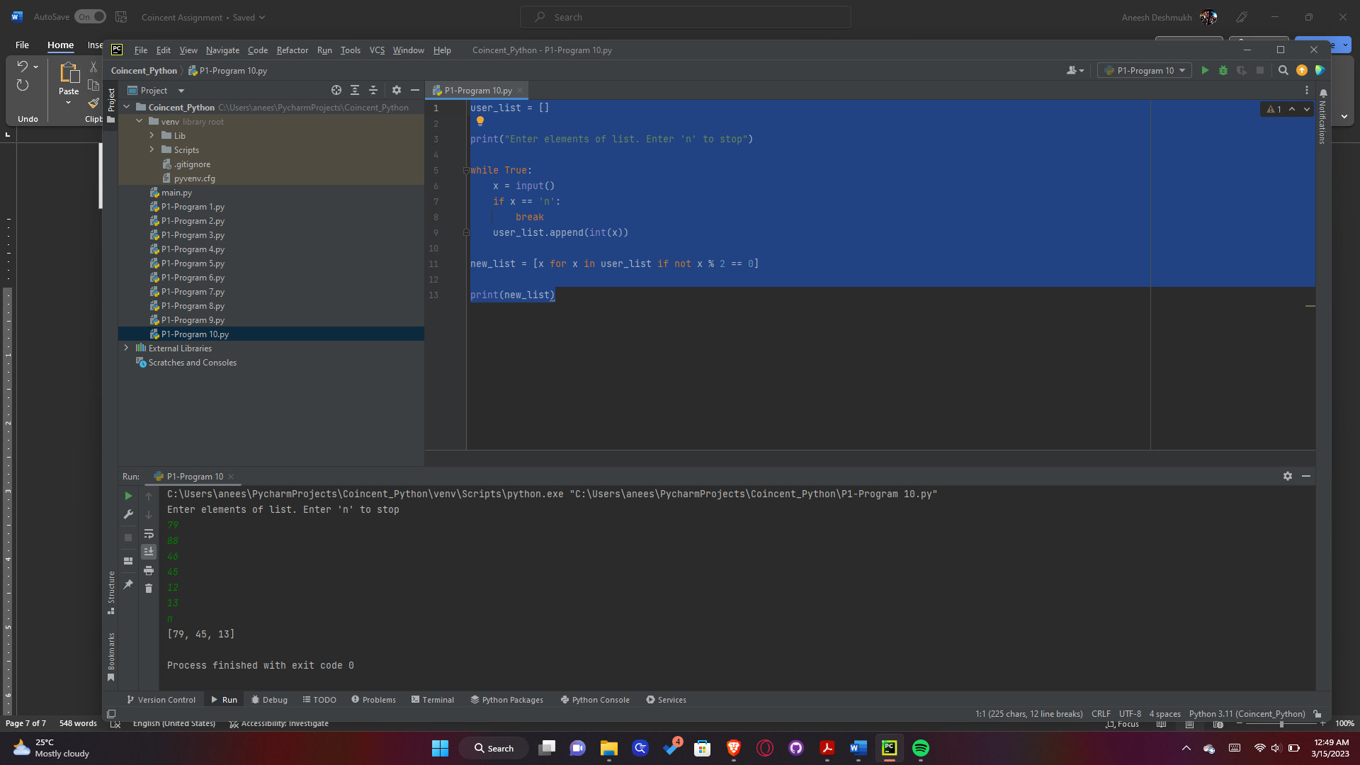Output:

1. Write a program to print lower case letter when you have upper case letter in string and vice-versa.

Program:

s = input("Enter string: ")  
  
print(s.swapcase())

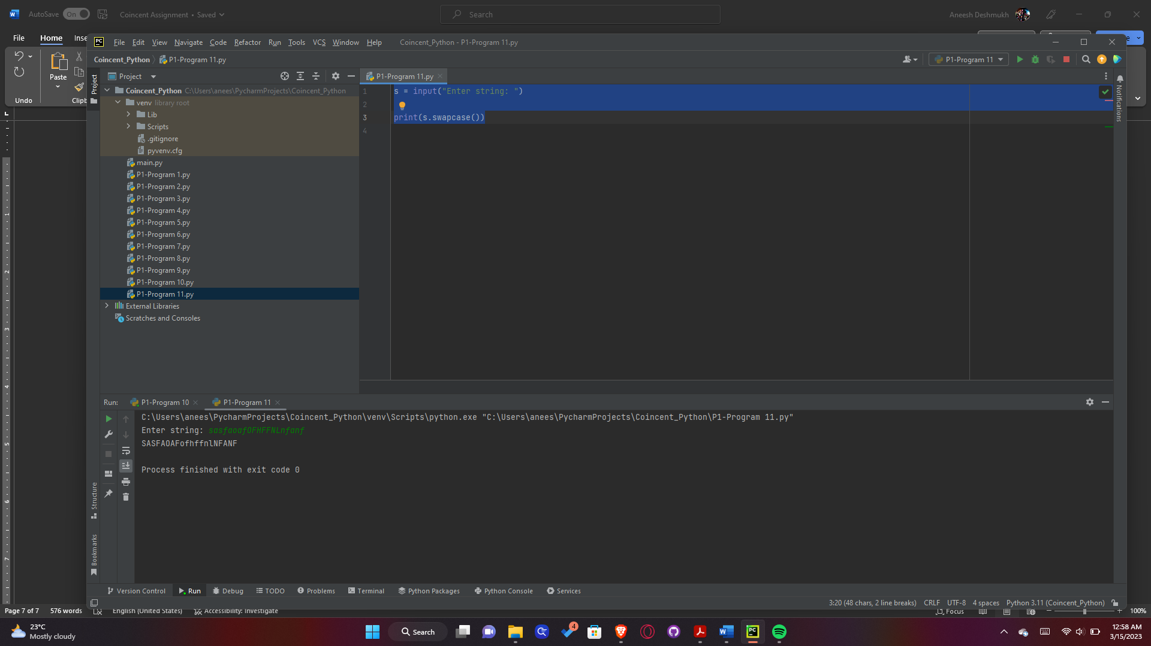Output:

**PART 2:**

**Iris Flower Classification using different algorithms**

Code:

import pandas as pd

import numpy as np

import plotly

import plotly.express as px

import plotly.offline as pyo

import cufflinks as cf

from plotly.offline import init_notebook_mode,plot,iplot

import matplotlib.pyplot as plt

%matplotlib inline

from sklearn.metrics import accuracy_score

import os

pyo.init_notebook_mode(connected=True)

cf.go_offline()

iris=pd.read_csv('/content/Iris.csv')

iris

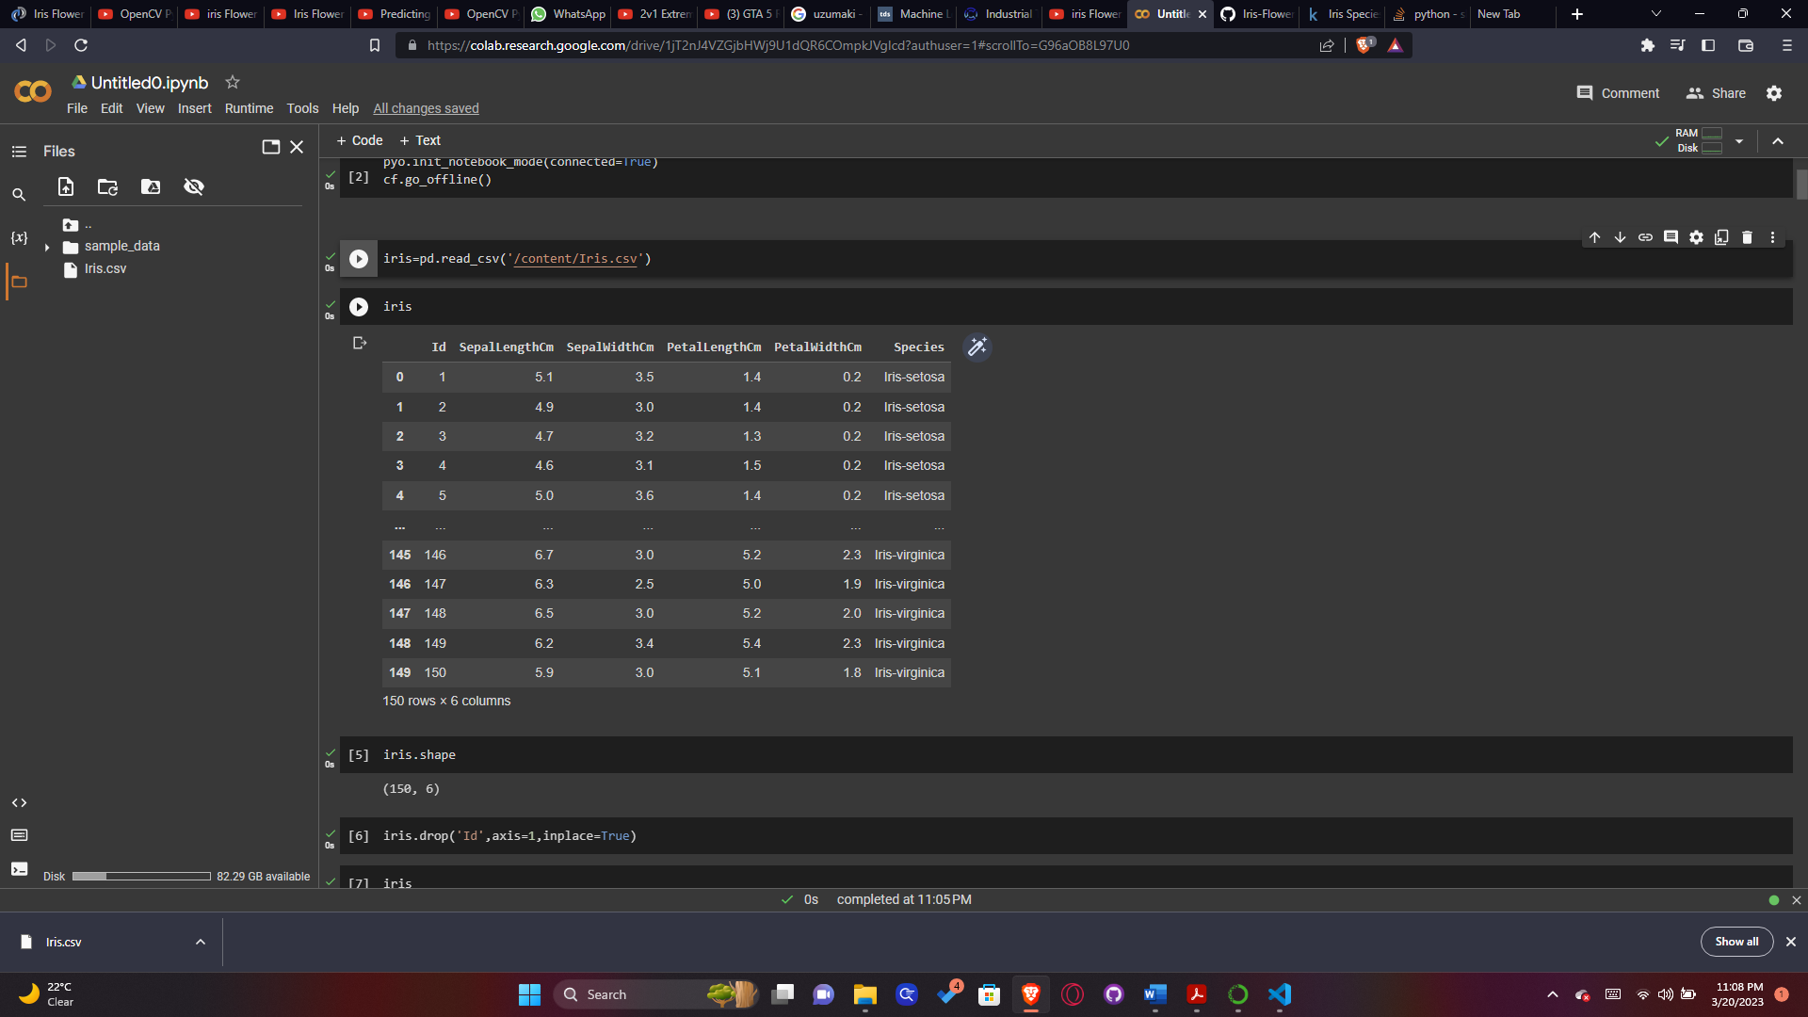

iris.shape

(150, 6)

iris.drop('Id',axis=1,inplace=True)

iris

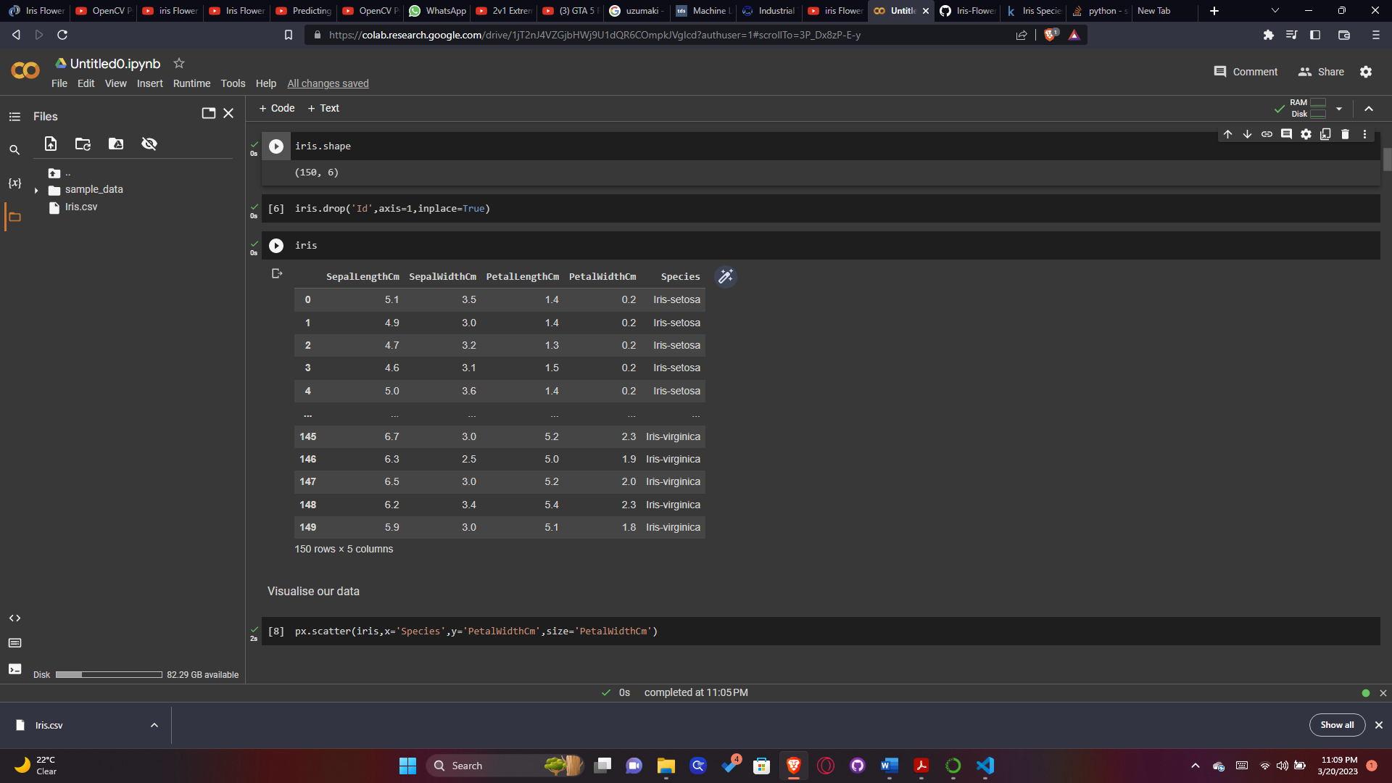

# Visualise our data

plt.bar(iris['Species'],iris['PetalWidthCm'])

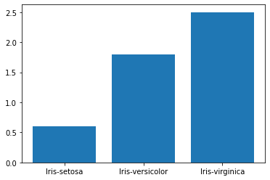

iris.rename(columns={'SepalLengthCm':'SepalLength','SepalWidthCm':'SepalWidth','PetalWidthCm':'PetalWidth','PetalLengthCm':'PetalLength'},inplace=True)

iris

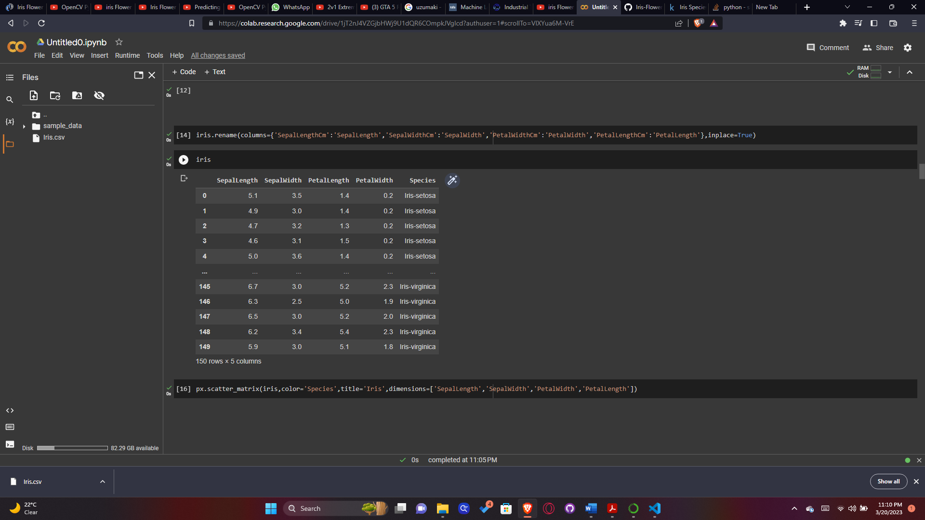

# Data Preprocessing

iris



X=iris.drop(['Species'],axis=1)

X

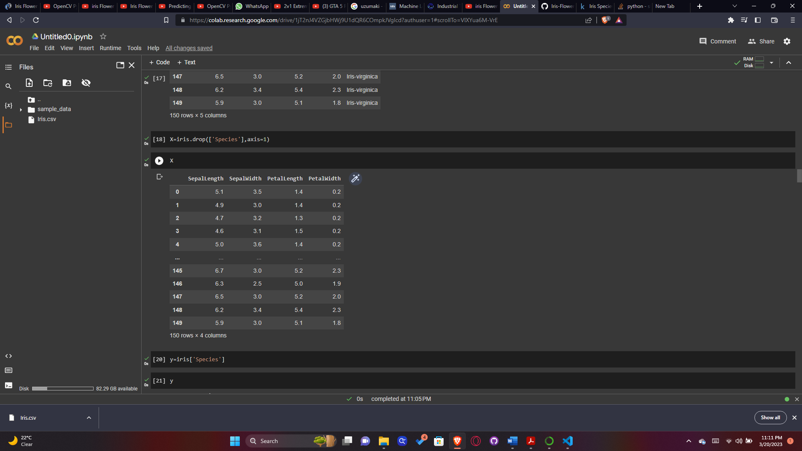

y=iris['Species']

y

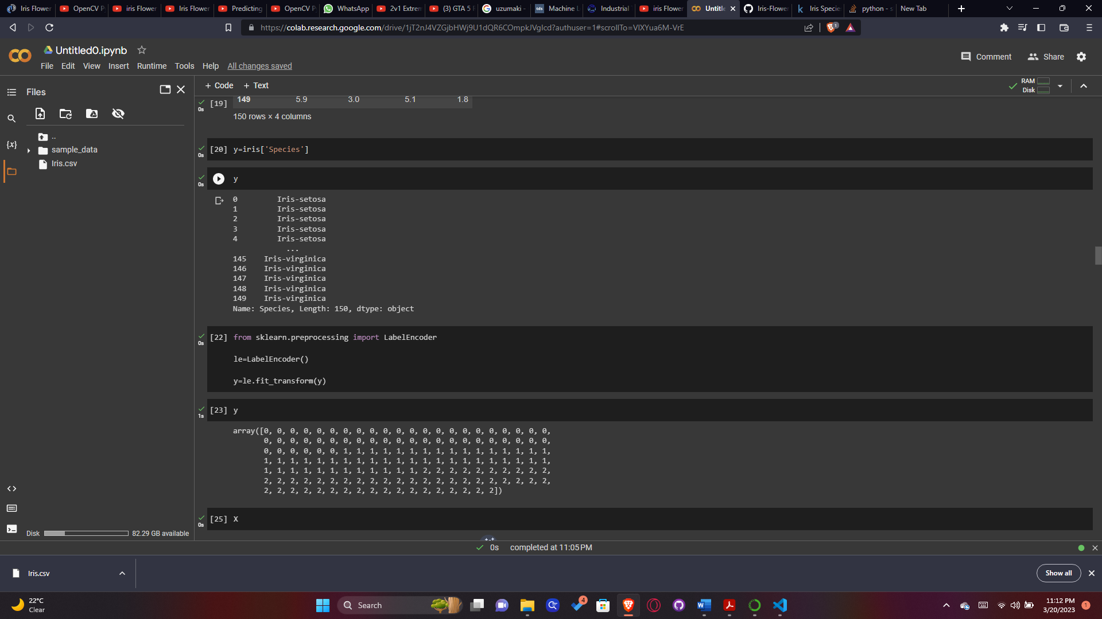

from sklearn.preprocessing import LabelEncoder

le=LabelEncoder()

y=le.fit_transform(y)

y

array([0, 0, 0, 0, 0, 0, 0, 0, 0, 0, 0, 0, 0, 0, 0, 0, 0, 0, 0, 0, 0, 0, 0, 0, 0, 0, 0, 0, 0, 0, 0, 0, 0, 0, 0, 0, 0, 0, 0, 0, 0, 0, 0, 0, 0, 0, 0, 0, 0, 0, 1, 1, 1, 1, 1, 1, 1, 1, 1, 1, 1, 1, 1, 1, 1, 1, 1, 1, 1, 1, 1, 1, 1, 1, 1, 1, 1, 1, 1, 1, 1, 1, 1, 1, 1, 1, 1, 1, 1, 1, 1, 1, 1, 1, 1, 1, 1, 1, 1, 1, 2, 2, 2, 2, 2, 2, 2, 2, 2, 2, 2, 2, 2, 2, 2, 2, 2, 2, 2, 2, 2, 2, 2, 2, 2, 2, 2, 2, 2, 2, 2, 2, 2, 2, 2, 2, 2, 2, 2, 2, 2, 2, 2, 2, 2, 2, 2, 2, 2, 2])

X

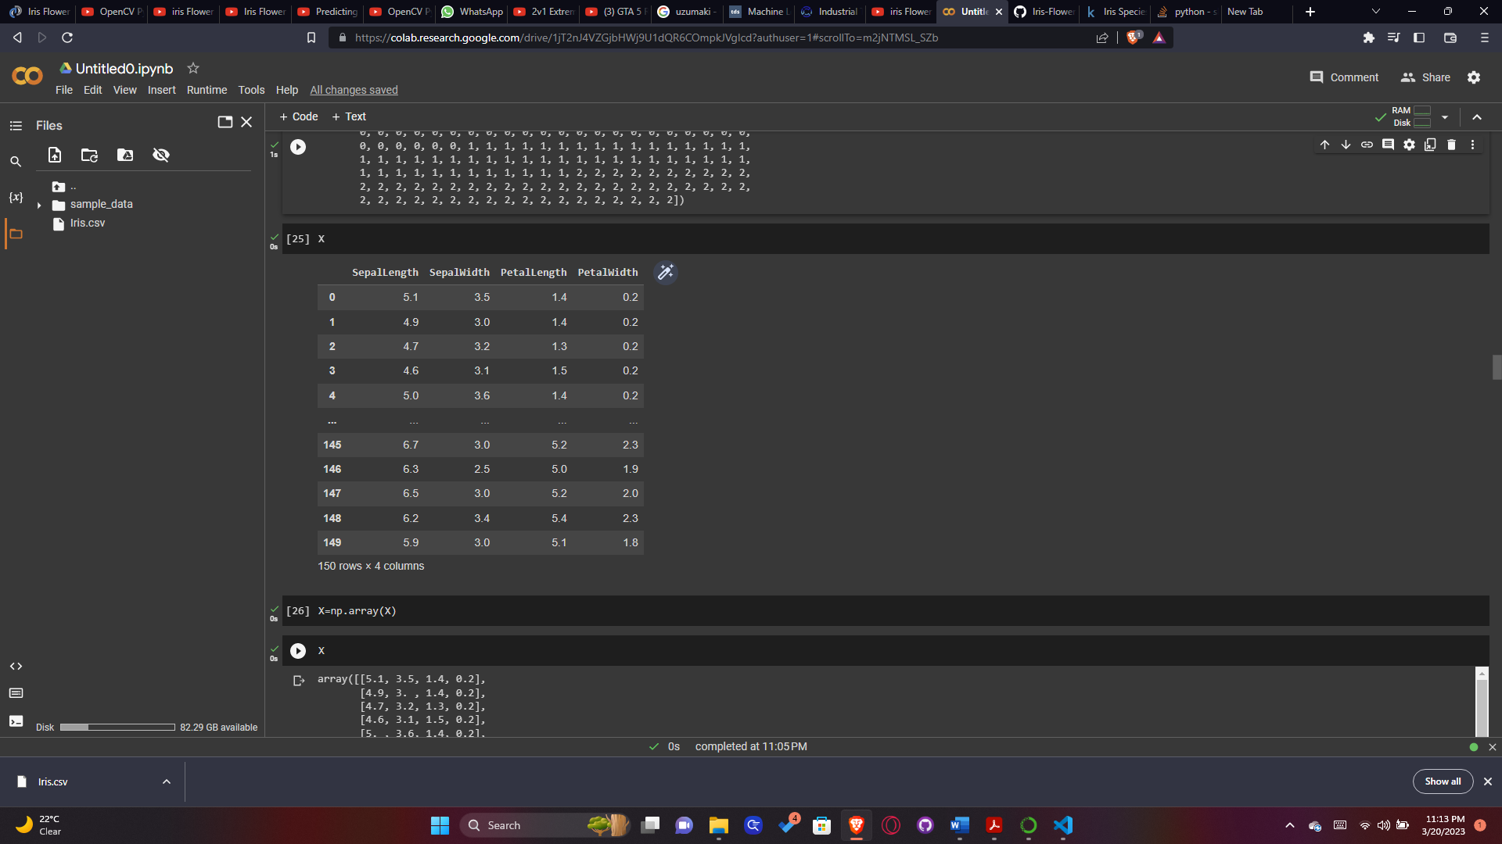

X=np.array(X)

X

array([[5.1, 3.5, 1.4, 0.2], [4.9, 3. , 1.4, 0.2], [4.7, 3.2, 1.3, 0.2], [4.6, 3.1, 1.5, 0.2], [5. , 3.6, 1.4, 0.2], [5.4, 3.9, 1.7, 0.4], [4.6, 3.4, 1.4, 0.3], [5. , 3.4, 1.5, 0.2], [4.4, 2.9, 1.4, 0.2], [4.9, 3.1, 1.5, 0.1], [5.4, 3.7, 1.5, 0.2], [4.8, 3.4, 1.6, 0.2], [4.8, 3. , 1.4, 0.1], [4.3, 3. , 1.1, 0.1], [5.8, 4. , 1.2, 0.2], [5.7, 4.4, 1.5, 0.4], [5.4, 3.9, 1.3, 0.4], [5.1, 3.5, 1.4, 0.3], [5.7, 3.8, 1.7, 0.3], [5.1, 3.8, 1.5, 0.3], [5.4, 3.4, 1.7, 0.2], [5.1, 3.7, 1.5, 0.4], [4.6, 3.6, 1. , 0.2], [5.1, 3.3, 1.7, 0.5], [4.8, 3.4, 1.9, 0.2], [5. , 3. , 1.6, 0.2], [5. , 3.4, 1.6, 0.4], [5.2, 3.5, 1.5, 0.2], [5.2, 3.4, 1.4, 0.2], [4.7, 3.2, 1.6, 0.2], [4.8, 3.1, 1.6, 0.2], [5.4, 3.4, 1.5, 0.4], [5.2, 4.1, 1.5, 0.1], [5.5, 4.2, 1.4, 0.2], [4.9, 3.1, 1.5, 0.1], [5. , 3.2, 1.2, 0.2], [5.5, 3.5, 1.3, 0.2], [4.9, 3.1, 1.5, 0.1], [4.4, 3. , 1.3, 0.2], [5.1, 3.4, 1.5, 0.2], [5. , 3.5, 1.3, 0.3], [4.5, 2.3, 1.3, 0.3], [4.4, 3.2, 1.3, 0.2], [5. , 3.5, 1.6, 0.6], [5.1, 3.8, 1.9, 0.4], [4.8, 3. , 1.4, 0.3], [5.1, 3.8, 1.6, 0.2], [4.6, 3.2, 1.4, 0.2], [5.3, 3.7, 1.5, 0.2], [5. , 3.3, 1.4, 0.2], [7. , 3.2, 4.7, 1.4], [6.4, 3.2, 4.5, 1.5], [6.9, 3.1, 4.9, 1.5], [5.5, 2.3, 4. , 1.3], [6.5, 2.8, 4.6, 1.5], [5.7, 2.8, 4.5, 1.3], [6.3, 3.3, 4.7, 1.6], [4.9, 2.4, 3.3, 1. ], [6.6, 2.9, 4.6, 1.3], [5.2, 2.7, 3.9, 1.4], [5. , 2. , 3.5, 1. ], [5.9, 3. , 4.2, 1.5], [6. , 2.2, 4. , 1. ], [6.1, 2.9, 4.7, 1.4], [5.6, 2.9, 3.6, 1.3], [6.7, 3.1, 4.4, 1.4], [5.6, 3. , 4.5, 1.5], [5.8, 2.7, 4.1, 1. ], [6.2, 2.2, 4.5, 1.5], [5.6, 2.5, 3.9, 1.1], [5.9, 3.2, 4.8, 1.8], [6.1, 2.8, 4. , 1.3], [6.3, 2.5, 4.9, 1.5], [6.1, 2.8, 4.7, 1.2], [6.4, 2.9, 4.3, 1.3], [6.6, 3. , 4.4, 1.4], [6.8, 2.8, 4.8, 1.4], [6.7, 3. , 5. , 1.7], [6. , 2.9, 4.5, 1.5], [5.7, 2.6, 3.5, 1. ], [5.5, 2.4, 3.8, 1.1], [5.5, 2.4, 3.7, 1. ], [5.8, 2.7, 3.9, 1.2], [6. , 2.7, 5.1, 1.6], [5.4, 3. , 4.5, 1.5], [6. , 3.4, 4.5, 1.6], [6.7, 3.1, 4.7, 1.5], [6.3, 2.3, 4.4, 1.3], [5.6, 3. , 4.1, 1.3], [5.5, 2.5, 4. , 1.3], [5.5, 2.6, 4.4, 1.2], [6.1, 3. , 4.6, 1.4], [5.8, 2.6, 4. , 1.2], [5. , 2.3, 3.3, 1. ], [5.6, 2.7, 4.2, 1.3], [5.7, 3. , 4.2, 1.2], [5.7, 2.9, 4.2, 1.3], [6.2, 2.9, 4.3, 1.3], [5.1, 2.5, 3. , 1.1], [5.7, 2.8, 4.1, 1.3], [6.3, 3.3, 6. , 2.5], [5.8, 2.7, 5.1, 1.9], [7.1, 3. , 5.9, 2.1], [6.3, 2.9, 5.6, 1.8], [6.5, 3. , 5.8, 2.2], [7.6, 3. , 6.6, 2.1], [4.9, 2.5, 4.5, 1.7], [7.3, 2.9, 6.3, 1.8], [6.7, 2.5, 5.8, 1.8], [7.2, 3.6, 6.1, 2.5], [6.5, 3.2, 5.1, 2. ], [6.4, 2.7, 5.3, 1.9], [6.8, 3. , 5.5, 2.1], [5.7, 2.5, 5. , 2. ], [5.8, 2.8, 5.1, 2.4], [6.4, 3.2, 5.3, 2.3], [6.5, 3. , 5.5, 1.8], [7.7, 3.8, 6.7, 2.2], [7.7, 2.6, 6.9, 2.3], [6. , 2.2, 5. , 1.5], [6.9, 3.2, 5.7, 2.3], [5.6, 2.8, 4.9, 2. ], [7.7, 2.8, 6.7, 2. ], [6.3, 2.7, 4.9, 1.8], [6.7, 3.3, 5.7, 2.1], [7.2, 3.2, 6. , 1.8], [6.2, 2.8, 4.8, 1.8], [6.1, 3. , 4.9, 1.8], [6.4, 2.8, 5.6, 2.1], [7.2, 3. , 5.8, 1.6], [7.4, 2.8, 6.1, 1.9], [7.9, 3.8, 6.4, 2. ], [6.4, 2.8, 5.6, 2.2], [6.3, 2.8, 5.1, 1.5], [6.1, 2.6, 5.6, 1.4], [7.7, 3. , 6.1, 2.3], [6.3, 3.4, 5.6, 2.4], [6.4, 3.1, 5.5, 1.8], [6. , 3. , 4.8, 1.8], [6.9, 3.1, 5.4, 2.1], [6.7, 3.1, 5.6, 2.4], [6.9, 3.1, 5.1, 2.3], [5.8, 2.7, 5.1, 1.9], [6.8, 3.2, 5.9, 2.3], [6.7, 3.3, 5.7, 2.5], [6.7, 3. , 5.2, 2.3], [6.3, 2.5, 5. , 1.9], [6.5, 3. , 5.2, 2. ], [6.2, 3.4, 5.4, 2.3], [5.9, 3. , 5.1, 1.8]])

from sklearn.model_selection import train_test_split

X_train,X_test,y_train,y_test=train_test_split(X,y,test_size=0.3,random_state=0)

X_test

array([[5.8, 2.8, 5.1, 2.4], [6. , 2.2, 4. , 1. ], [5.5, 4.2, 1.4, 0.2], [7.3, 2.9, 6.3, 1.8], [5. , 3.4, 1.5, 0.2], [6.3, 3.3, 6. , 2.5], [5. , 3.5, 1.3, 0.3], [6.7, 3.1, 4.7, 1.5], [6.8, 2.8, 4.8, 1.4], [6.1, 2.8, 4. , 1.3], [6.1, 2.6, 5.6, 1.4], [6.4, 3.2, 4.5, 1.5], [6.1, 2.8, 4.7, 1.2], [6.5, 2.8, 4.6, 1.5], [6.1, 2.9, 4.7, 1.4], [4.9, 3.1, 1.5, 0.1], [6. , 2.9, 4.5, 1.5], [5.5, 2.6, 4.4, 1.2], [4.8, 3. , 1.4, 0.3], [5.4, 3.9, 1.3, 0.4], [5.6, 2.8, 4.9, 2. ], [5.6, 3. , 4.5, 1.5], [4.8, 3.4, 1.9, 0.2], [4.4, 2.9, 1.4, 0.2], [6.2, 2.8, 4.8, 1.8], [4.6, 3.6, 1. , 0.2], [5.1, 3.8, 1.9, 0.4], [6.2, 2.9, 4.3, 1.3], [5. , 2.3, 3.3, 1. ], [5. , 3.4, 1.6, 0.4], [6.4, 3.1, 5.5, 1.8], [5.4, 3. , 4.5, 1.5], [5.2, 3.5, 1.5, 0.2], [6.1, 3. , 4.9, 1.8], [6.4, 2.8, 5.6, 2.2], [5.2, 2.7, 3.9, 1.4], [5.7, 3.8, 1.7, 0.3], [6. , 2.7, 5.1, 1.6], [5.9, 3. , 4.2, 1.5], [5.8, 2.6, 4. , 1.2], [6.8, 3. , 5.5, 2.1], [4.7, 3.2, 1.3, 0.2], [6.9, 3.1, 5.1, 2.3], [5. , 3.5, 1.6, 0.6], [5.4, 3.7, 1.5, 0.2]])

X_test.size

180

iris

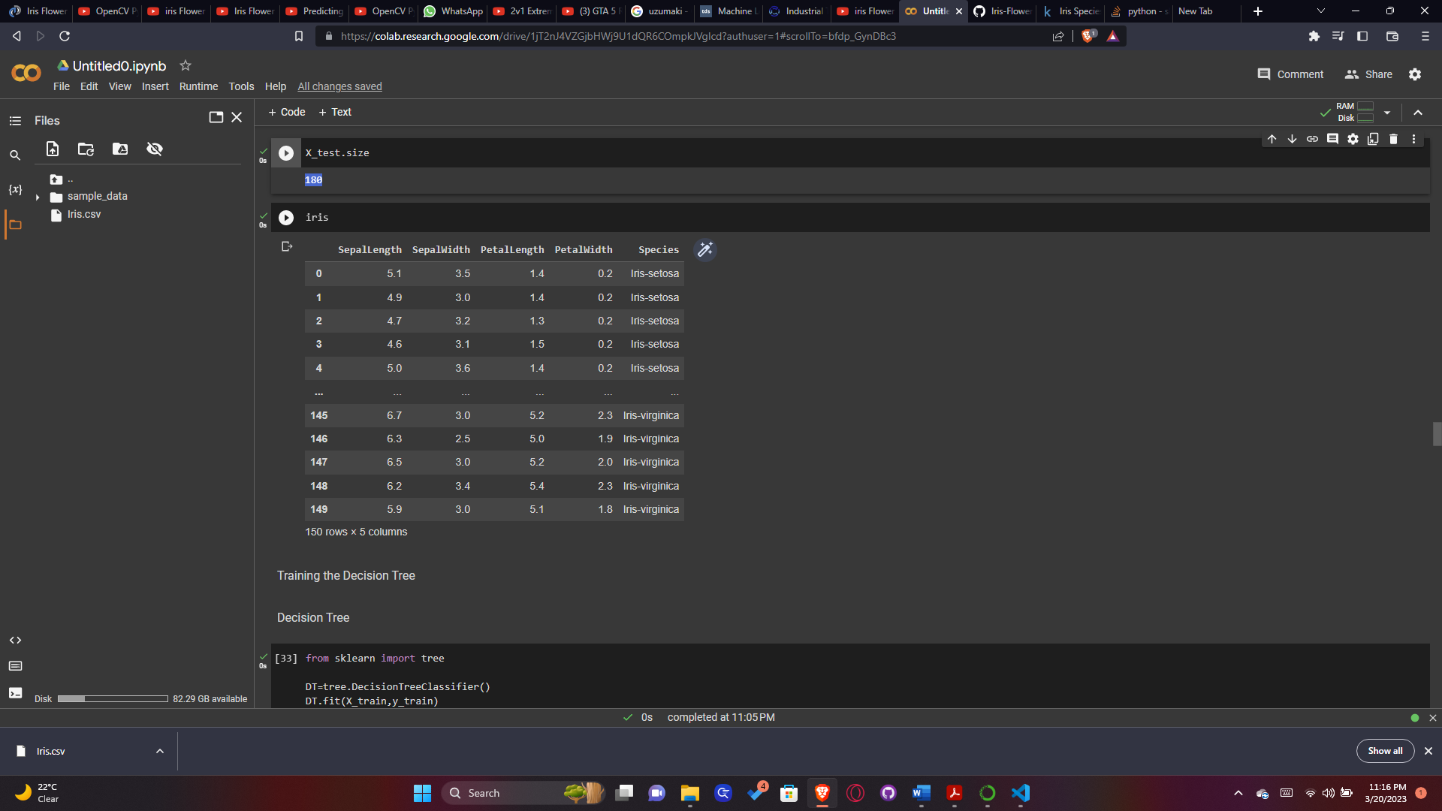

# Training the Decision Tree

# Decision Tree

from sklearn import tree

DT=tree.DecisionTreeClassifier()

DT.fit(X_train,y_train)

y_train.size

105

prediction_DT=DT.predict(X_test)

accuracy_DT=accuracy_score(y_test,prediction_DT)*100

accuracy_DT

97.77777777777777

y_test

array([2, 1, 0, 2, 0, 2, 0, 1, 1, 1, 2, 1, 1, 1, 1, 0, 1, 1, 0, 0, 2, 1, 0, 0, 2, 0, 0, 1, 1, 0, 2, 1, 0, 2, 2, 1, 0, 1, 1, 1, 2, 0, 2, 0, 0])

prediction_DT

array([2, 1, 0, 2, 0, 2, 0, 1, 1, 1, 2, 1, 1, 1, 1, 0, 1, 1, 0, 0, 2, 1, 0, 0, 2, 0, 0, 1, 1, 0, 2, 1, 0, 2, 2, 1, 0, 2, 1, 1, 2, 0, 2, 0, 0])

os.environ["PATH"]+= os.pathsep+(r'C:\Python37\Graph_Viz\bin')

import graphviz

vis_data=tree.export_graphviz(DT,out_file=None, feature_names=iris.drop(['Species'],axis=1).keys(),class_names=iris['Species'].unique(),filled=True,rounded=True,special_characters=True)

graphviz.Source(vis_data)

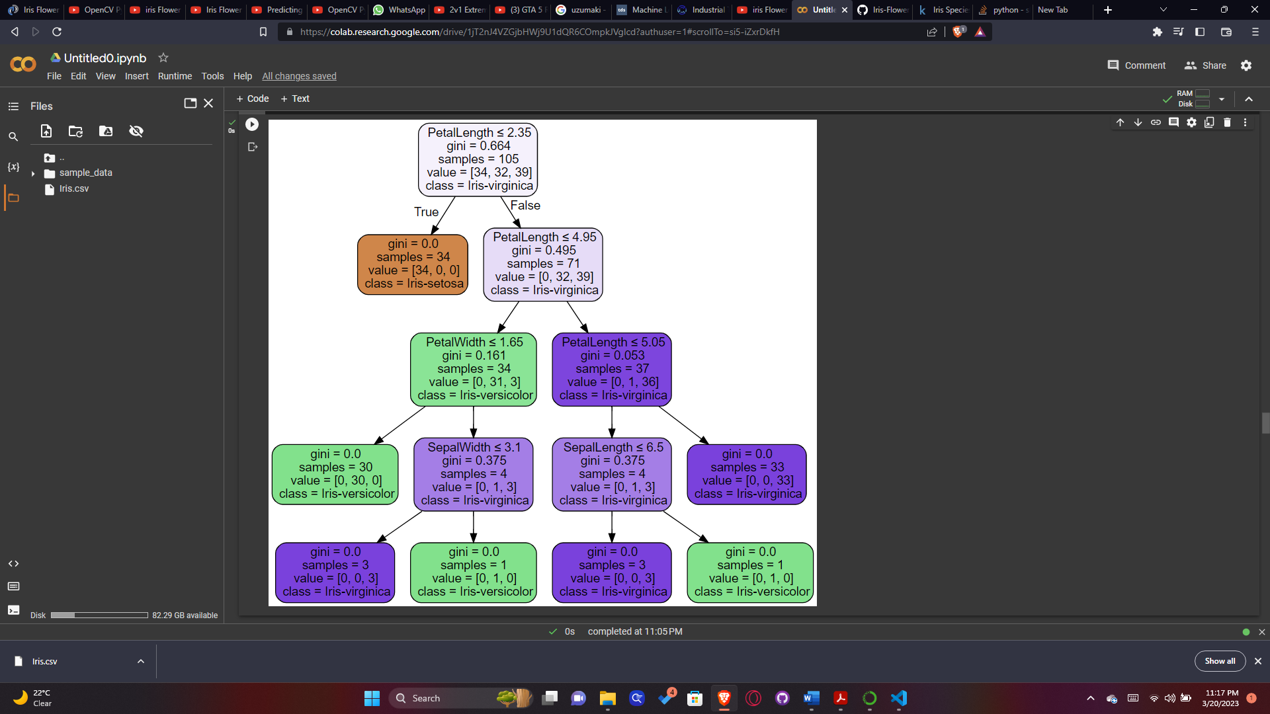

Catagory=['Iris-Setosa','Iris-Versicolor','Iris-Virginica']

#Lets predict on custom input value

X_DT=np.array([[1 ,1, 1, 1]])

X_DT_prediction=DT.predict(X_DT)

X_DT_prediction[0]

print(Catagory[int(X_DT_prediction[0])])

Iris-Setosa

# KNN Algorithm

# Preprocessing for Knn

from sklearn.preprocessing import StandardScaler

sc = StandardScaler().fit(X_train) # Load the standard scaler

X_train_std=sc.transform(X_train)

X_test_std=sc.transform(X_test)

from sklearn.neighbors import KNeighborsClassifier

knn=KNeighborsClassifier(n_neighbors=5)

knn.fit(X_train_std,y_train)

predict_knn=knn.predict(X_test_std)

accuracy_knn=accuracy_score(y_test,predict_knn)*100

accuracy_knn

97.77777777777777

#Lets predict on custom input value

X_knn=np.array([[7.7 ,3.5, 4.6, 4]])

X_knn_std=sc.transform(X_knn)

X_knn_std

array([[2.07024529, 1.03637663, 0.42953569, 3.56608443]])

X_knn_prediction=knn.predict(X_knn_std)

X_knn_prediction[0]

print(Catagory[int(X_knn_prediction[0])])

Iris-Virginica

#Finding Best K Value

k_range=range(1,26)

scores={}

scores_list=[]

for k in k_range:

knn=KNeighborsClassifier(n_neighbors=k)

knn.fit(X_train_std,y_train)

prediction_knn=knn.predict(X_test_std)

scores[k]=accuracy_score(y_test,prediction_knn)

scores_list.append(accuracy_score(y_test,prediction_knn))

scores_list

[0.9333333333333333, 0.9555555555555556, 0.9777777777777777, 0.9777777777777777, 0.9777777777777777, 0.9777777777777777, 0.9777777777777777, 0.9777777777777777, 0.9777777777777777, 0.9777777777777777, 0.9777777777777777, 0.9777777777777777, 0.9777777777777777, 0.9777777777777777, 0.9777777777777777, 0.9777777777777777, 0.9555555555555556, 0.9777777777777777, 0.9333333333333333, 0.9555555555555556, 0.9333333333333333, 0.9555555555555556, 0.9333333333333333, 0.9111111111111111, 0.9111111111111111]

plt.plot(k_range,scores_list)

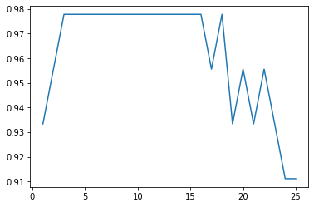

#K MEANS Clustering

y

array([0, 0, 0, 0, 0, 0, 0, 0, 0, 0, 0, 0, 0, 0, 0, 0, 0, 0, 0, 0, 0, 0, 0, 0, 0, 0, 0, 0, 0, 0, 0, 0, 0, 0, 0, 0, 0, 0, 0, 0, 0, 0, 0, 0, 0, 0, 0, 0, 0, 0, 1, 1, 1, 1, 1, 1, 1, 1, 1, 1, 1, 1, 1, 1, 1, 1, 1, 1, 1, 1, 1, 1, 1, 1, 1, 1, 1, 1, 1, 1, 1, 1, 1, 1, 1, 1, 1, 1, 1, 1, 1, 1, 1, 1, 1, 1, 1, 1, 1, 1, 2, 2, 2, 2, 2, 2, 2, 2, 2, 2, 2, 2, 2, 2, 2, 2, 2, 2, 2, 2, 2, 2, 2, 2, 2, 2, 2, 2, 2, 2, 2, 2, 2, 2, 2, 2, 2, 2, 2, 2, 2, 2, 2, 2, 2, 2, 2, 2, 2, 2])

colormap=np.array(['Red','green','blue'])

fig=plt.scatter(iris['PetalLength'],iris['PetalWidth'],c=colormap[y],s=50)

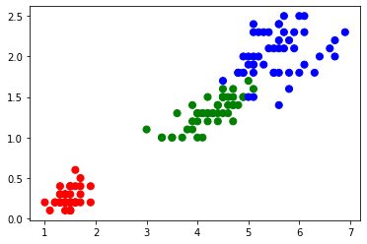

from sklearn.cluster import KMeans

km=KMeans(n_clusters=3,n_init=4,random_state=2)

km.fit(X)

centers=km.cluster_centers_

print(centers)

[[5.006 3.418 1.464 0.244 ]

[5.9016129 2.7483871 4.39354839 1.43387097]

[6.85 3.07368421 5.74210526 2.07105263]]

km.labels_

array([0, 0, 0, 0, 0, 0, 0, 0, 0, 0, 0, 0, 0, 0, 0, 0, 0, 0, 0, 0, 0, 0, 0, 0, 0, 0, 0, 0, 0, 0, 0, 0, 0, 0, 0, 0, 0, 0, 0, 0, 0, 0, 0, 0, 0, 0, 0, 0, 0, 0, 1, 1, 2, 1, 1, 1, 1, 1, 1, 1, 1, 1, 1, 1, 1, 1, 1, 1, 1, 1, 1, 1, 1, 1, 1, 1, 1, 2, 1, 1, 1, 1, 1, 1, 1, 1, 1, 1, 1, 1, 1, 1, 1, 1, 1, 1, 1, 1, 1, 1, 2, 1, 2, 2, 2, 2, 1, 2, 2, 2, 2, 2, 2, 1, 1, 2, 2, 2, 2, 1, 2, 1, 2, 1, 2, 2, 1, 1, 2, 2, 2, 2, 2, 1, 2, 2, 2, 2, 1, 2, 2, 2, 1, 2, 2, 2, 1, 2, 2, 1], dtype=int32)

Catagory_kmeans=['Iris-Versicolor', 'Iris-Setosa', 'Iris-Virginica']

Catagory_kmeans

['Iris-Versicolor', 'Iris-Setosa', 'Iris-Virginica']

colormap=np.array(['Red','green','blue'])

fig=plt.scatter(iris['PetalLength'],iris['PetalWidth'],c=colormap[km.labels_],s=50)

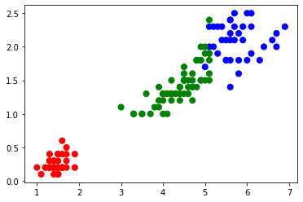

new_labels=km.labels_

fig,axes=plt.subplots(1,2,figsize=(16,8))

axes[0].scatter(X[:,2],X[:,3],c=y,cmap='gist_rainbow',edgecolor='k',s=150)

axes[1].scatter(X[:,2],X[:,3],c=y,cmap='jet',edgecolor='k',s=150)

axes[0].set_title('Actual',fontsize=18)

axes[1].set_title('Predicted',fontsize=18)

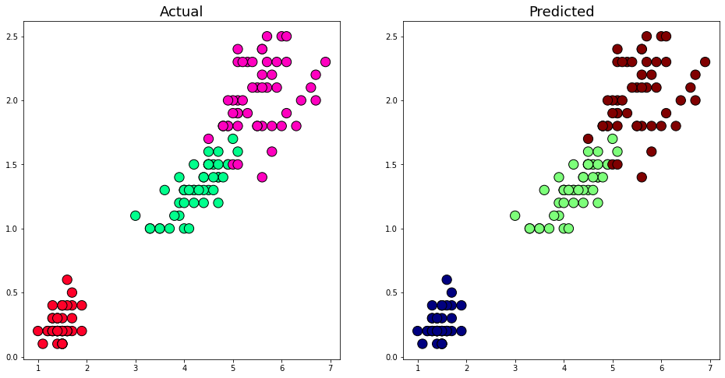

#Lets predict on custom input value

X_km=np.array([[1 ,1, 1, 1]])

X_km_prediction=km.predict(X_km)

X_km_prediction[0]

print(Catagory_kmeans[int(X_km_prediction[0])])

Iris-Versicolor

**PART 3:**

**Haar cascade algorithm for face detection**

haarcascade_frontalface_default.xml file taken from https://github.com/opencv/opencv/tree/master/data/haarcascades

Code:

import cv2

face_cascade = cv2.CascadeClassifier('haarcascade_frontalface_default.xml')

img = cv2.imread('test 2.jpg')

gray = cv2.cvtColor(img, cv2.COLOR_BGR2GRAY)

faces = face_cascade.detectMultiScale(gray, 1.1, 4)

for (x, y, w, h) in faces:

    cv2.rectangle(img, (x, y), (x+w, y+h), (0, 255, 0), 3)

cv2.imshow('img', img)

cv2.waitKey()

Output:

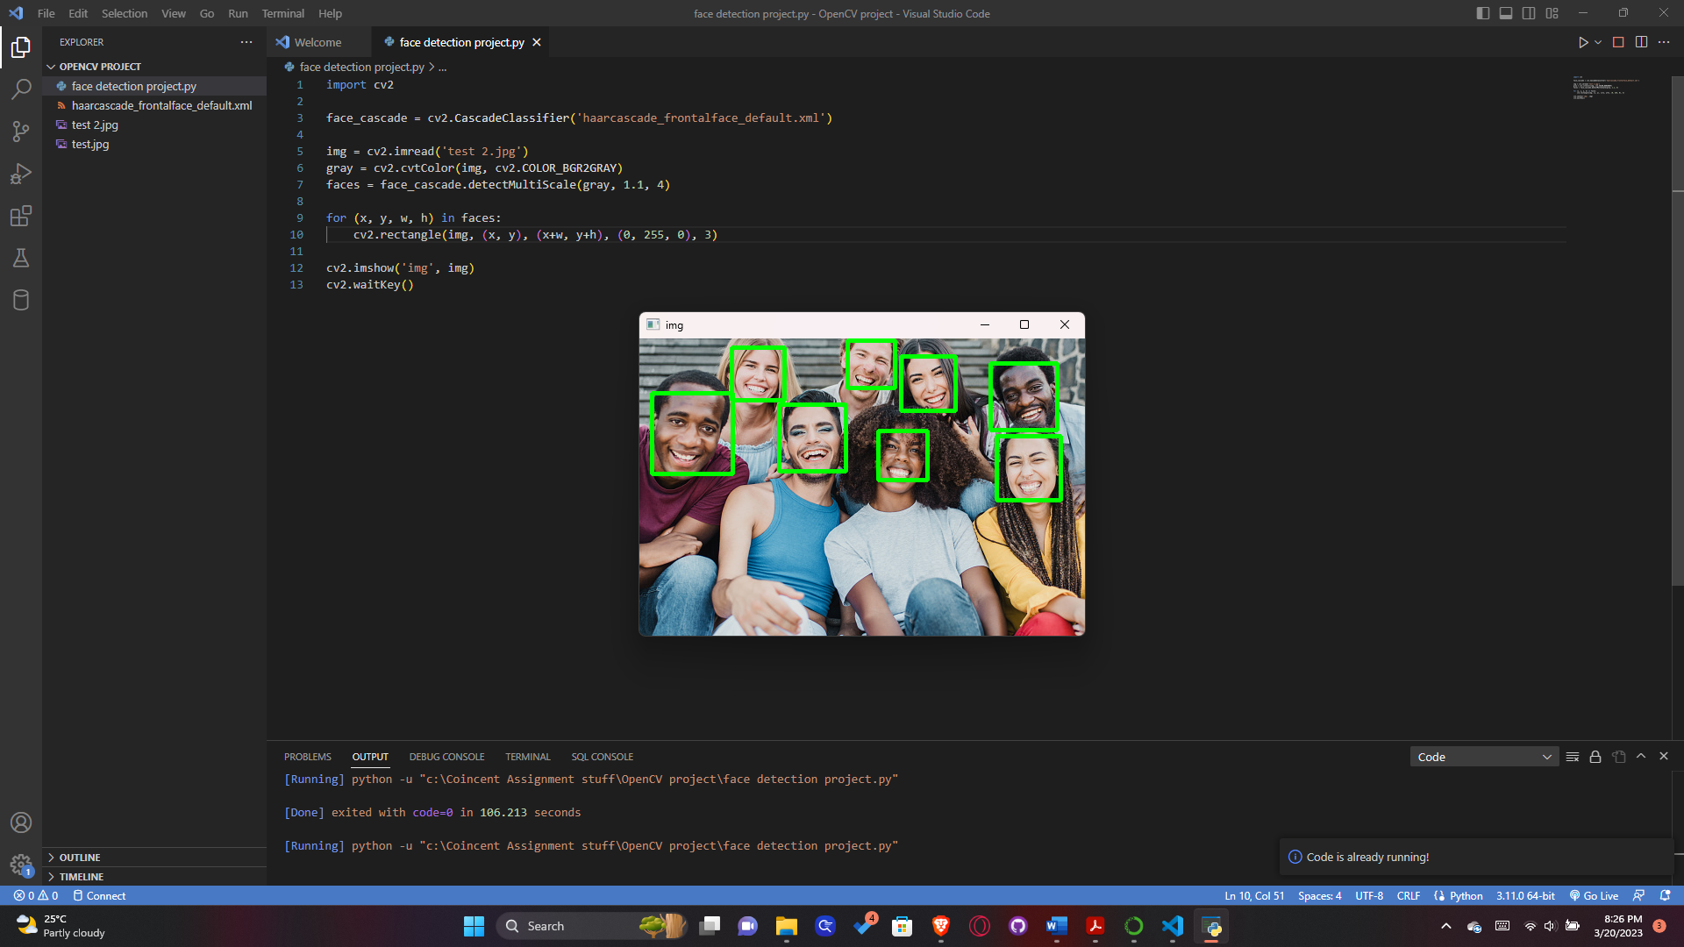

**PART 4:**

**Boston Housing Classifier (using Google Collab)**

Code:

import pandas as pd

import matplotlib.pyplot as plt

import seaborn as sns

boston = pd.read_csv('/content/housing (2).csv')

boston.head()

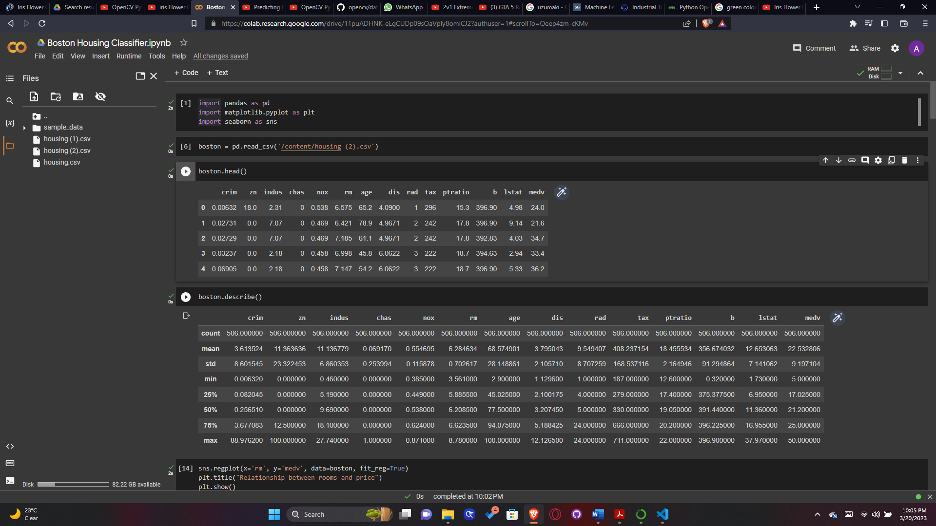

boston.describe()



sns.regplot(x='rm', y='medv', data=boston, fit_reg=True)

plt.title("Relationship between rooms and price")

plt.show()

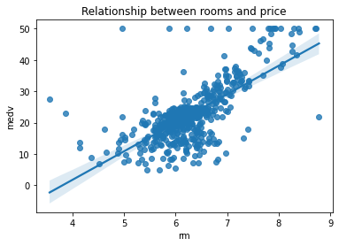

# showing a few more plots

sns.regplot(y='medv', x='lstat', data=boston, fit_reg=True)

plt.show()

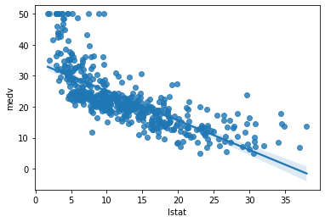

sns.regplot(x='nox', y='medv', data=boston, fit_reg=True)

plt.show()

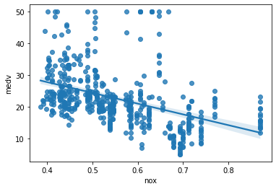

sns.regplot(y='medv', x='dis', data=boston, fit_reg=True)

plt.show()

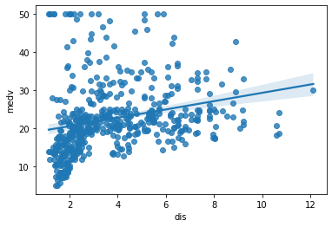

sns.regplot(x='ptratio', y='medv', data=boston, fit_reg=True)

plt.show()

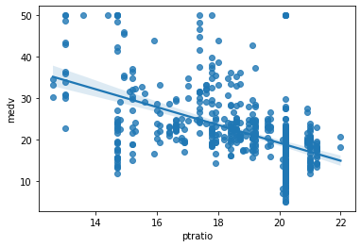

sns.regplot(x='crim', y='medv', data=boston, fit_reg=True)

plt.show()

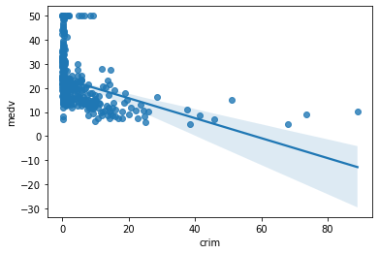

plt.hist(boston.crim)

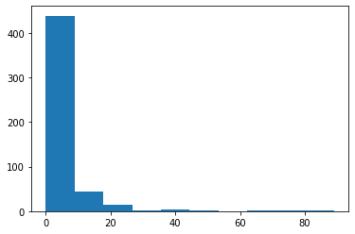

import numpy as np

plt.hist(np.log(boston.crim))

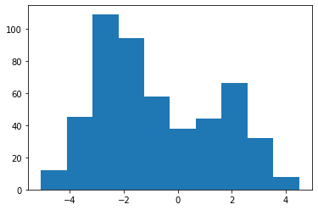

# showing a few more histograms

plt.hist(boston.rm)

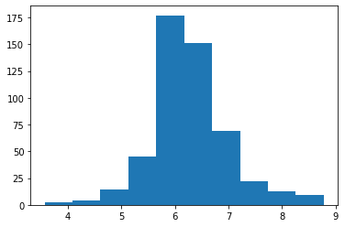

plt.hist(boston.lstat)

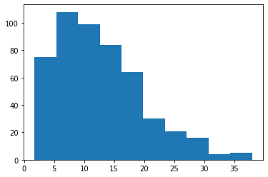

plt.hist(boston.nox)

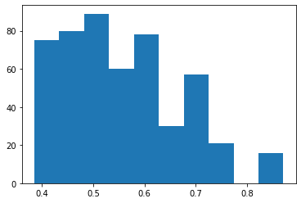

plt.hist(boston.ptratio)

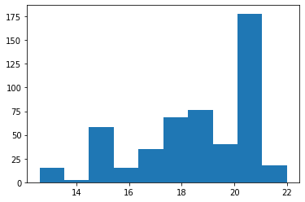

boston.columns

Index(['crim', 'zn', 'indus', 'chas', 'nox', 'rm', 'age', 'dis', 'rad', 'tax', 'ptratio', 'b', 'lstat', 'medv'], dtype='object')

boston_selected_var_df = boston.iloc[:,[0,4,5,7,10,11,12]]

boston_selected_var_df.head()

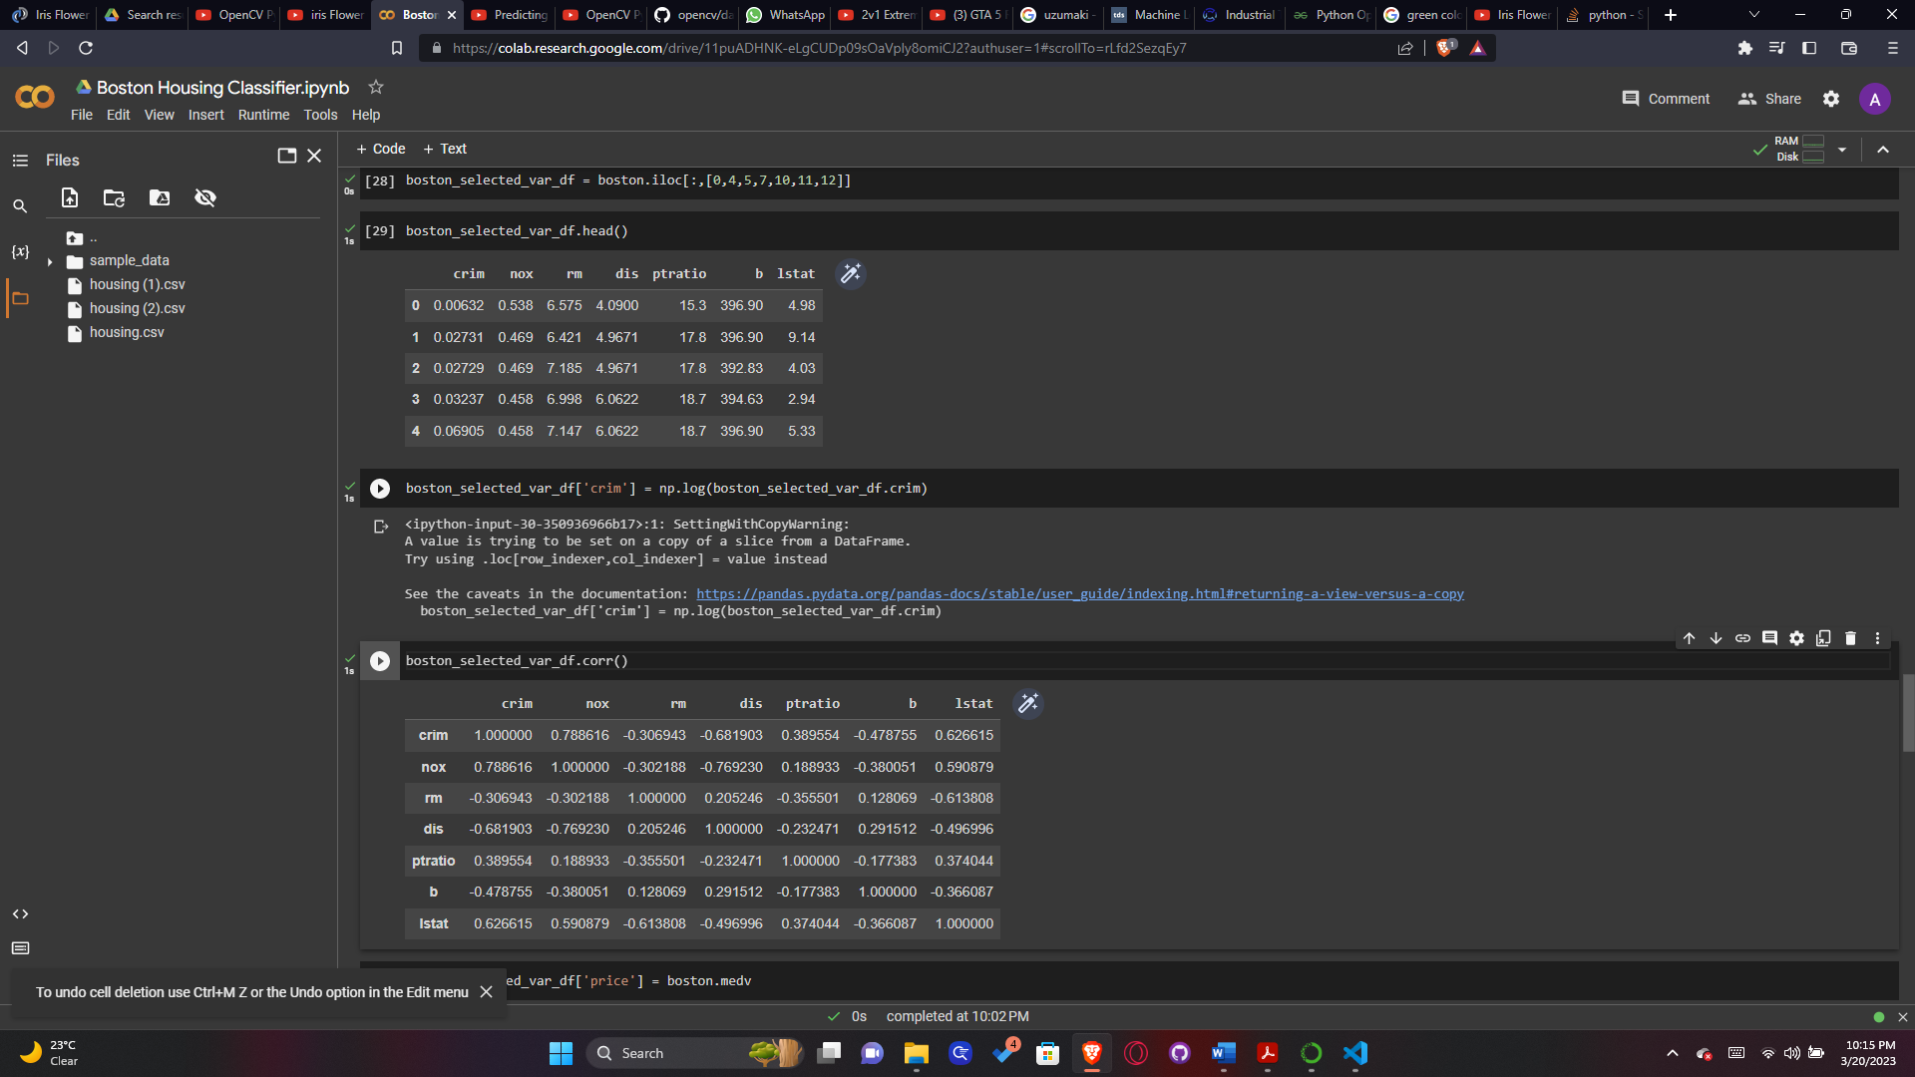

boston_selected_var_df['crim'] = np.log(boston_selected_var_df.crim)

boston_selected_var_df.corr()



boston_selected_var_df['price'] = boston.medv

import statsmodels.api as sm

from statsmodels.formula.api import ols

model = ols('price ~ crim + nox + rm + dis + ptratio+lstat',boston_selected_var_df).fit()

print(model.summary())

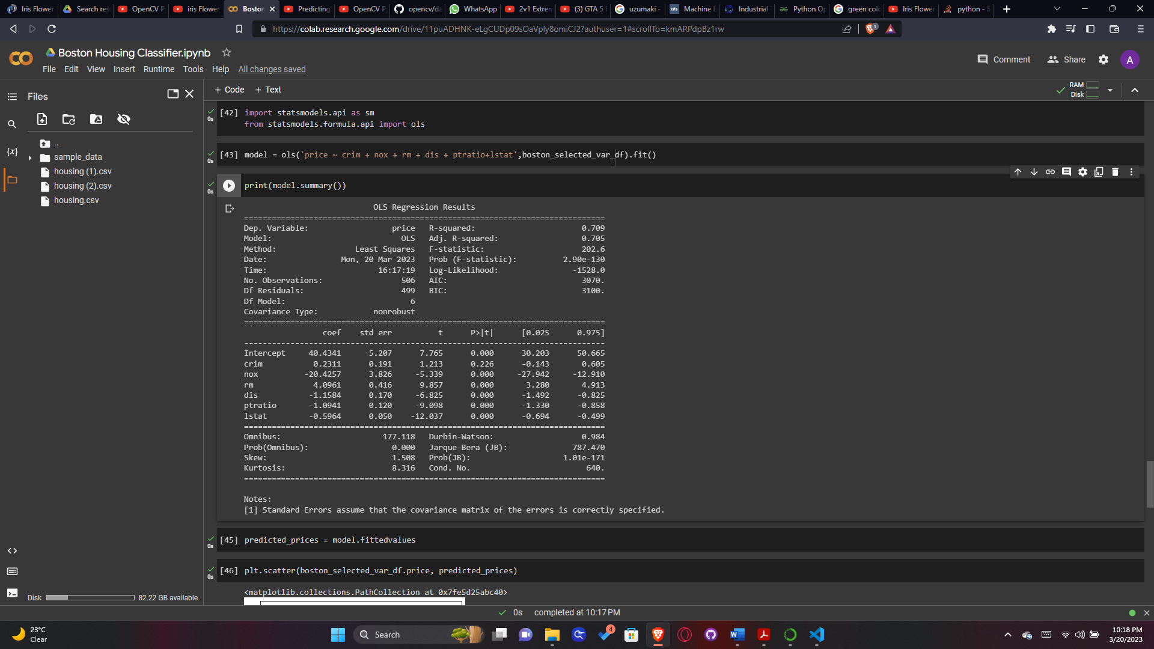

predicted_prices = model.fittedvalues

plt.scatter(boston_selected_var_df.price, predicted_prices)

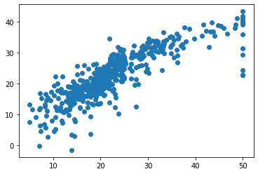

from sklearn.metrics import mean_squared_error

error = np.sqrt(mean_squared_error(boston_selected_var_df.price, predicted_prices))

error

4.9568674667600074

from sklearn.model_selection import train_test_split

x = boston_selected_var_df.drop('price', axis=1)

y = boston_selected_var_df['price']

X_train, X_test, Y_train, Y_test = train_test_split(x, y, test_size=.3, random_state=3)

from sklearn.linear_model import LinearRegression

LinReg = LinearRegression()

LinReg.fit(X_train, Y_train)

Y_pred = LinReg.predict(X_test)

plt.scatter(Y_test, Y_pred)

<matplotlib.collections.PathCollection at 0x7fe5d17dcfd0>

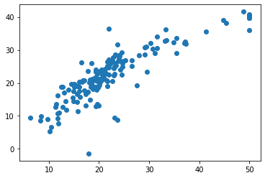

np.sqrt(mean_squared_error(Y_test, Y_pred))

4.650074744839381